MTSS Overview
Harlan County Schools
What is MTSS?
MTSS is an integrated educational framework designed for continuous improvement and student support utilizing a systematic process of data-based decision making and problem solving. It is designed to promote student flourishing and minimize the risk for long-term negative consequences when systems and supports do not adjust to meet student need. MTSS focuses on the whole child (academics, behavior, and social-emotional learning) so that “each and every student is equipped and empowered for a successful future” (KDE).

How is MTSS Defined?
KDE defines MTSS as, “a multi-level prevention system to support student achievement and social-emotional behavioral competencies through and integration of differentiated core instruction, assessment, and intervention.

How Does MTSS Differ from RTI?
MTSS address the whole child whereas RTI focused primarily on academics. RTI is one aspect of the MTSS system that considers Reading, Math, and Writing. MTSS continues the RTI process of analyzing and intervening for behavior and adds social-emotional learning in order to consider all aspects of student learning. A crosswalk demonstrating the integration of systems can be found here: https://education.ky.gov/curriculum/standards/teachtools/Documents/Crosswalk_KyMTSS_RTI_PBIS_ISF.pdf

Is MTSS Special Education?
No, MTSS is regular education. MTSS is NOT a pathway directly to special education. MTSS includes universal, evidence-based differentiated instruction that is standards-driven and utilizes evidence-based, high-yield instructional strategies for ALL students. MTSS is a preventative system designed to close the gaps for at-risk students. MTSS is designed to improve student achievement and outcomes by providing appropriate supports to all students BEFORE critical deficits occur.
More information on standards, evidence-based instruction and high-yield strategies can be found here: https://kystandards.org/

What are the Essential Components of MTSS?

Essential Elements of MTSS

- Equitable Access and Opportunity for All Students
- Multi-Tiered Prevention System
- Academics, Behavior, SEL
- Data-Based Decision Making
- Evidence-Based Instruction, Intervention and Supports
- Collaborative Problem-Solving
- Partnerships

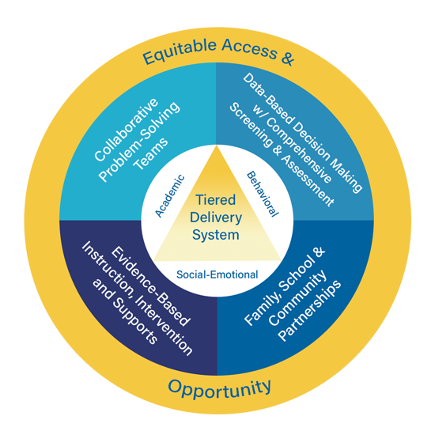

A detailed MTSS overview can be found here:
https://kymtss.org/overview/

The What, Why, and How of MTSS
What: A multi-tiered instructional delivery system.
Why: To provide equitable access and opportunity for all students so they benefit from standards-driven, evidence-based instruction.
How: Teams work together to analyze data to make instructional decisions and to communicate effectively to all stakeholders.

